**The Roots of British-Israel**

**Assembled by Warren Lunt**

**22 July 2023**

1. As long ago as the 6th Century A.D. an early British historian named “Gildas the Wise” wrote at the era when the pagan Saxon were invading Christian Celtic Britain. He wrote that these events were taking place so our Lord might demonstrate in this land His accustomed manner to these His Israelites whether they loved Him or not.
2. In 1314 A.D. the nobility of Scotland signed the Scottish Declaration of Independence at Arbroath Abbey. In it they stated their belief in the Israel Identity of their people: “We know and from the chronicles and books of the ancients gather, that the nation of the Scots passing from the greater Scythia through the Mediterranean Sea and the Pillars of Hercules (Straits of Gibraltar) and sojourning in Spain … and convey there one thousand two hundred years after the outgoing of the people of Israel”
3. Sir Francis Drake (1540-1596) wrote to Rev. John Foxe, the famous Martyrologist. “God may be glorified, His church, our Queen and country preserved, the enemies of truth vanquished, that we might have continued peace in Israel. Our enemies are many but our protector commandeth the whole earth”
4. French Huguenot Counsellor Le Loyer wrote in his “The Ten Lost Tribes Found” (1590) “The Israelites came to and founded the English Isles”
5. John Saddler M.A., M.P. – in 1649 in his learned work “Rights of the Kingdom or Customs of our Kings and Parliaments” advocated the Israelitish origins of the English.
6. In 1761 Alexander Cruden published the first edition of the famous Bible aid, “Crudens Concordance”. The dedication page of this original edition contained these words: – “that it may be said by the present and future ages, that King George III has been a Hezekiah to our British Israel”.
7. In 1813 – Ralph Wedgwood in his publication “The Book of Remembrance” demonstrated that England is Ephraim.
8. In 1815 – Rev. James Hartley Frere wrote a book entitled “A Combined View of the Prophecies of Daniel, Esdras and St John” in which he showed that the British were Israel.
9. In 1816 – Rev. B Murphy published “Precursory Proofs that the Israelites came into Egypt and Ireland; he went on to publish “The Advocate of Israel and the Isle of Erin”.
10. In 1828 – Rev. J W Brooks wrote an article which he signed Abdul which was published in the Jewish Chronicle and in which he proved the Welsh to be of Israel descent.
11. In 1840 – Rev. John Wilson M.A. a Scottish Presbyterian minister authored the classic book “Our Israelitish Origin” in which he combined the record of history and Bible Prophecy with the most up to date discoveries of archaeology. His writings and lectures helped to make the Israel Message widely known. (slightly abridged)

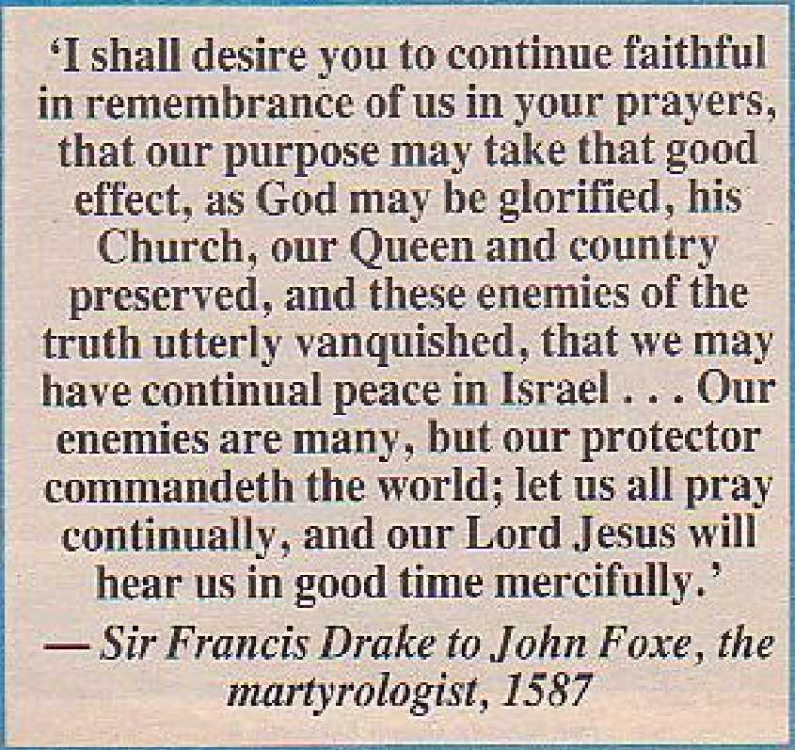

He did know of the concept. So did Sir Francis Drake, and John Foxe the writer of "Foxe's Book of Martyrs", about two centuries earlier, for a letter penned by Drake to Foxe in 1587 now rests as Harleian manuscript 167, folio 104, in the British Library, The British Museum.

Drake's Letter to John Foxe (Author, "Foxe's Book of Martyrs") 31.4K

